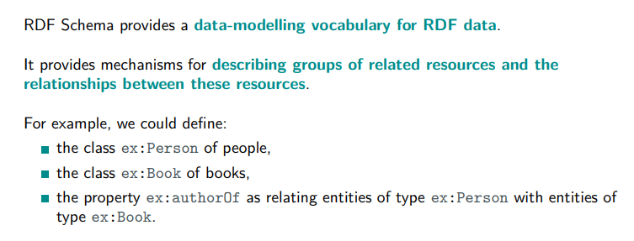

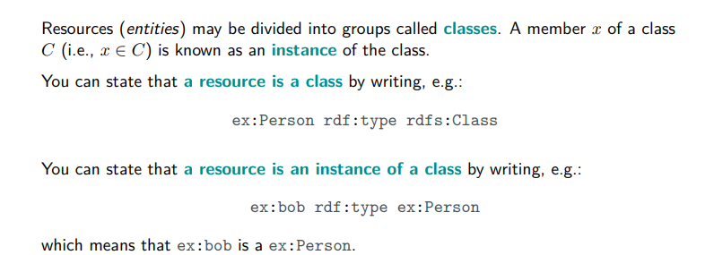

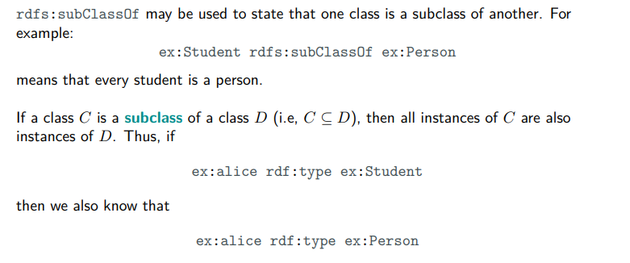

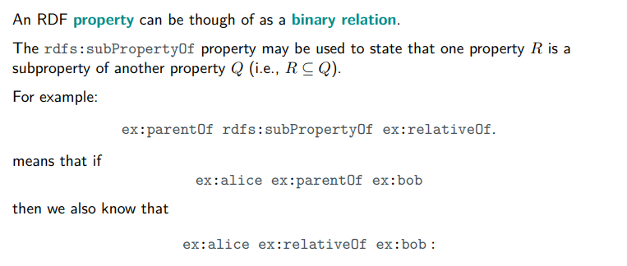

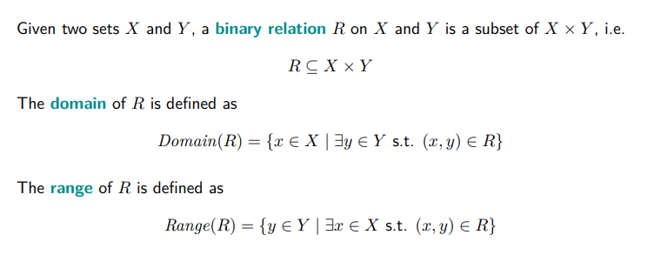

binary relation subset of the cartesian product

range: all the elements of the second set Y +compl

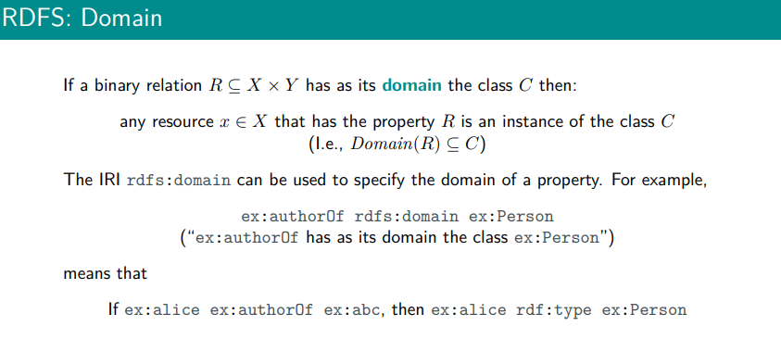

A binary relation

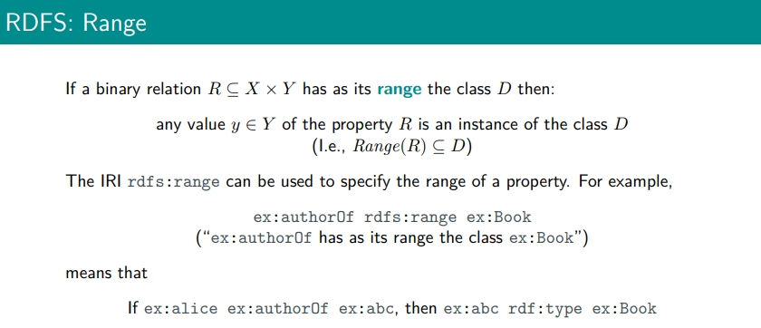

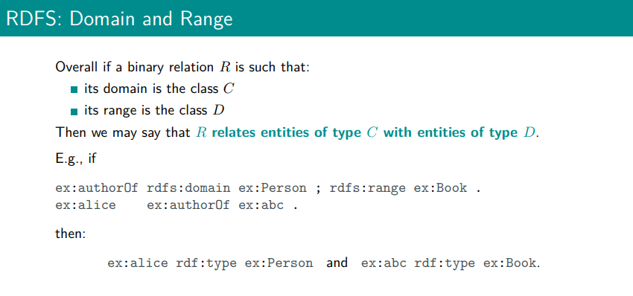

<http://ttl.summerofcode.be/> turtle validator

No prefix

@prefix :<<http://example.org>>.

:Person a rdf:Class.

:Student a rdf:Class.

:MusicAlbum a rdfs:Class.

:carol rdf:type :Student.

:Student rdfs:subClassOf :Person.

:like rdf:type rdf: Propertyu.

:purchase a rdf:Property.

:own a rdf:Property.

:DSOTM a :MusicAlbum

:bob :like :DSOTM

:DSOTM rdfs:label “The dark side of the moon”

:Meddie a :MusicAlbum.

:bob :purchase :Meddle.

:like rdfs:subPropertyOf :purhcase.

# if

:bob :like :DSOTM.

# then

:bob : purhcase :DSOTM.

:purchase rdfs:subPropertyOf :own.

:purchase :domain :Person.

: purchase :range :MusicAlbum.

# if

:bob :purchased DSTOM.

# then

:bob a :Person.

:DOSTM a :MusicAlbum

## Ex2

> e <